Extra Duty Examples:

G-Type: $2000 for Charlie Chapman, who is receiving extra for teaching Math.

Notes:
- G-Types are ‘lumped’ in with compensation of Primary Job for TRS reporting purposes. Amount is paid over 12 months (for Pay Frequency 6).
- A stipend for additional education is not considered Wholly Separate and should therefore be included in Stat Min calculations.
- You will need to determine whether the Stat Min contribution should be expensed to the code associated with the stipend or not and whether or not you want the stipend included in the dock rate.
- The TRS Position field will be grayed out since G-Types are automatically added to the primary job’s compensation when reporting to TRS.
- Also note for RP report that stipend 54 (Science Stipend is included in Stat Min calculations. (This will add $208.33 to the amount reported on the RP.)

In the Extra Duty Code table:

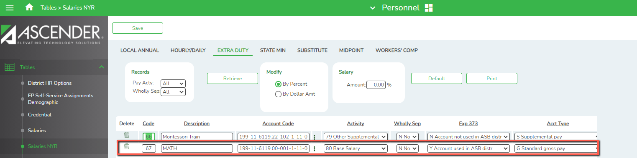
Continued…….

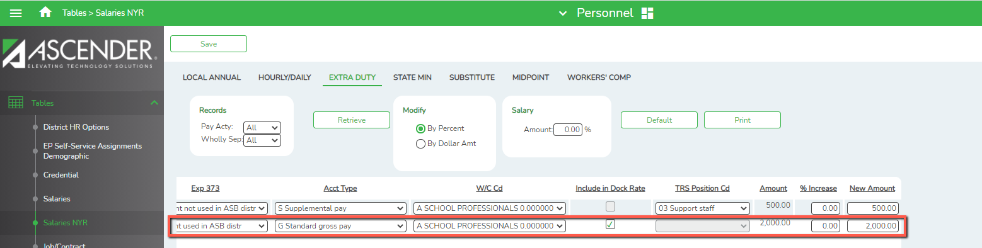

In the Pay Info tab:
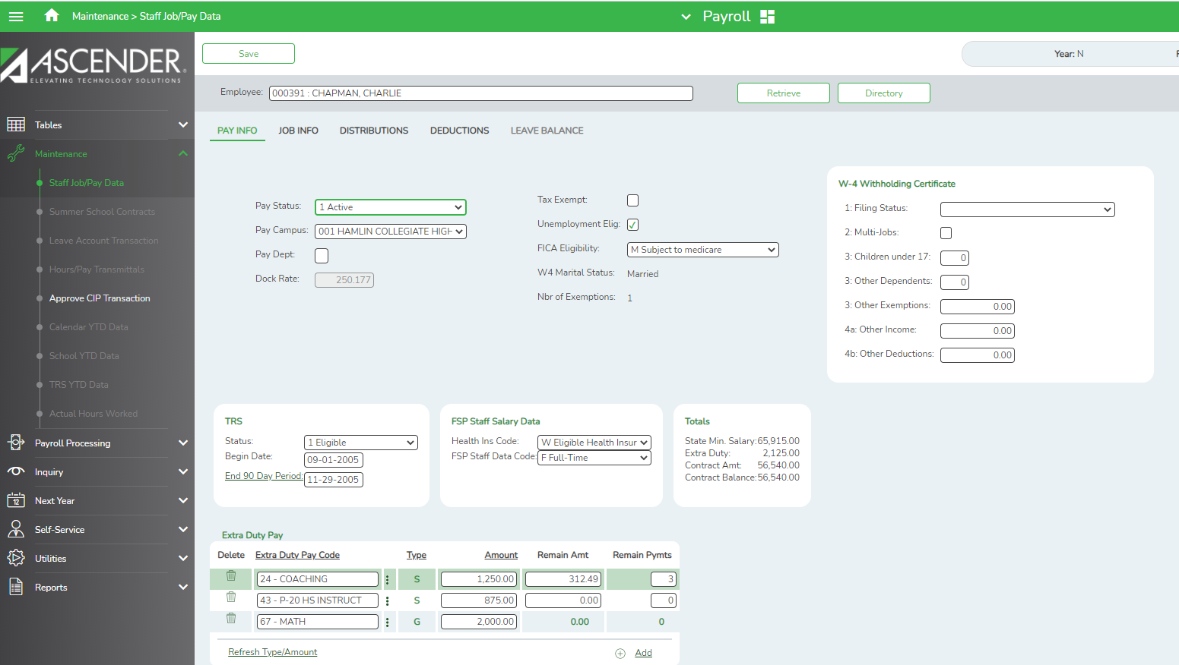
On the Job Info tab:
Notes for Job Info:
- Table shows salary for Step 20 = $54,540.
- G-Type Stipend is added when you Calculate so the total Contract amount is $56,540.

In the Distribution tab:

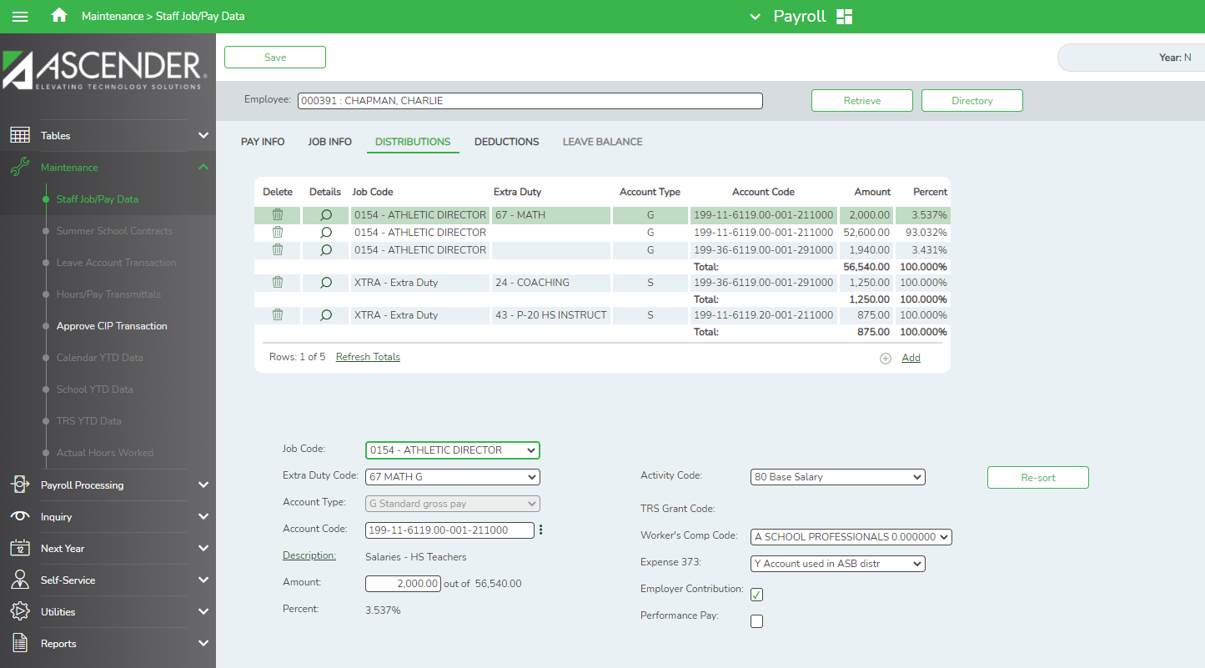

The RP Record:
Notes on RP:
- TRS Gross = $4711.67 + $104.17 = 4815.84 amount on Job Info screen (which includes the Math payment) + the Coaching Stipend for the month.

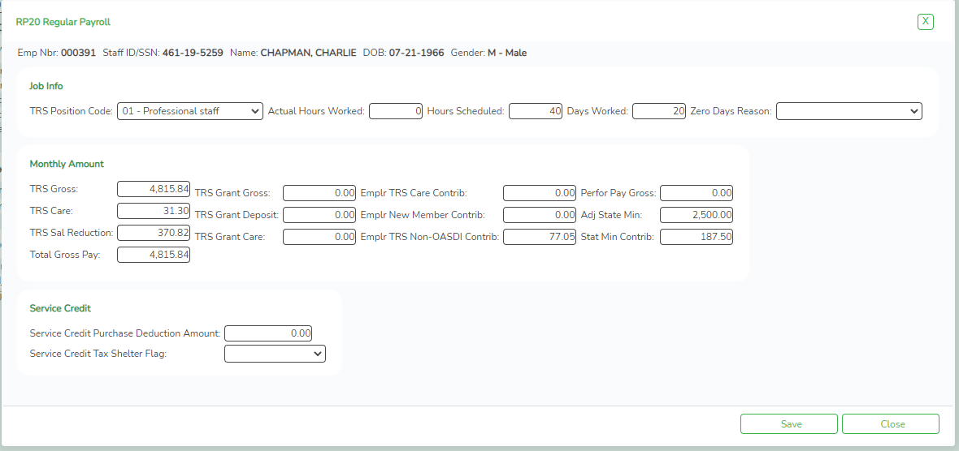

S-Type: $500 to Julie Andrews for NHS Sponsor

Notes:
- Julie also has an S-Type stipend as the NHS sponsor. This one is considered Wholly Separate since the district has determined that it is not subject to Stat Min calculations. The Expense 373 selection should be set to N to achieve the desired results.
- A TRS Position Code of 03 should be assigned. This will mean a separate RP record will be created. An ED40 will also be created for this duty.
- When S-Types are added to an employee’s Pay Info tab, you must determine the number of annual payments, the remaining amount, and remaining payments
- An Extra Duty Job line is automatically added to the Job Info tab. There will be only one line on the Job Info tab regardless of how many S-Types are added. When deleting, the line on the Job Info tab should be deleted also if there will be no remaining S-Types for the employee.

In the Extra Duty Code Table:

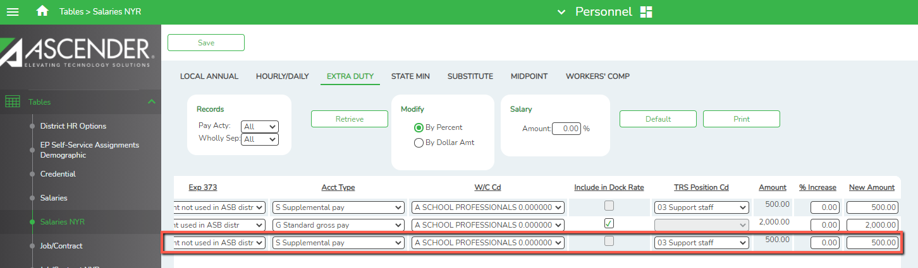
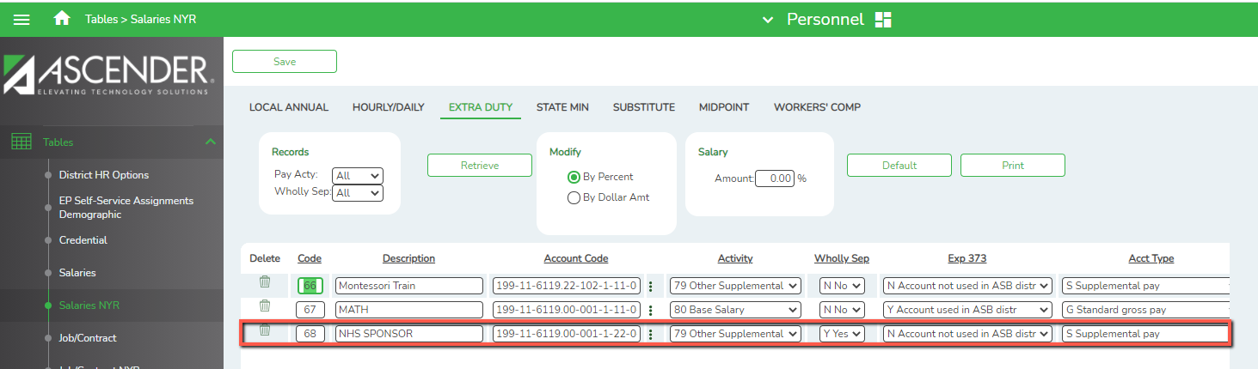Continued….

The RP Record:
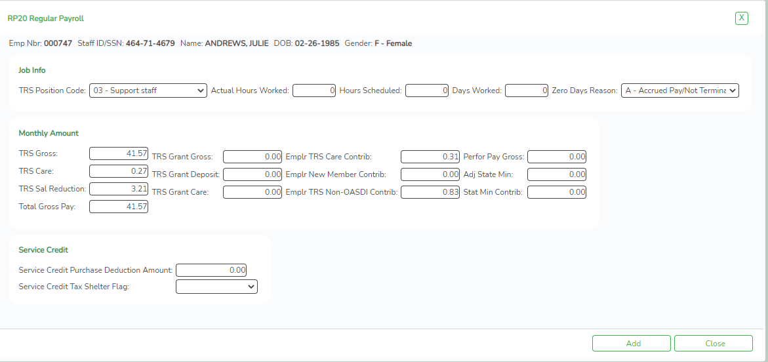

S-Type: $1,000 to Patsy Cline for Cheer Sponsor

Notes:
- Patsy Cline is an aide so no Stat Min will be calculated. The duty can be considered Wholly Separate or tied to a TRS Position Code 03.
- A TRS Position Code of 03 should be assigned. (Ascender currently defaults a blank Position Code 03, but we recommend always assigning to avoid confusion.)

In the Extra Duty Code table:
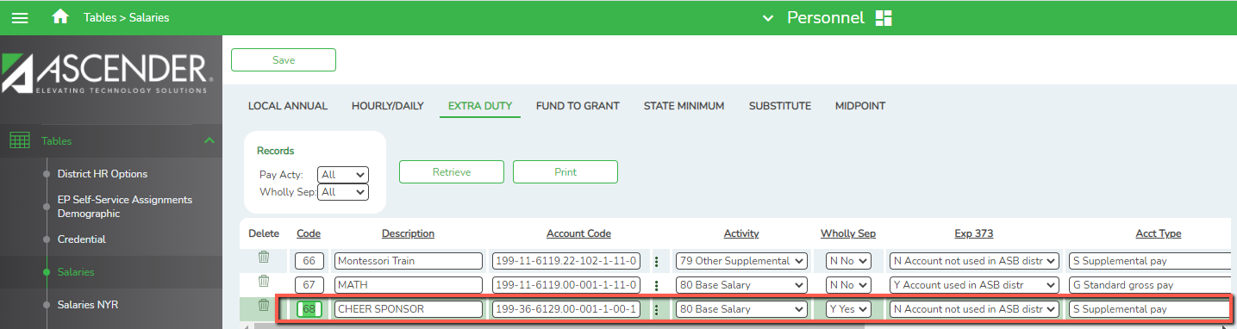
Continued…..

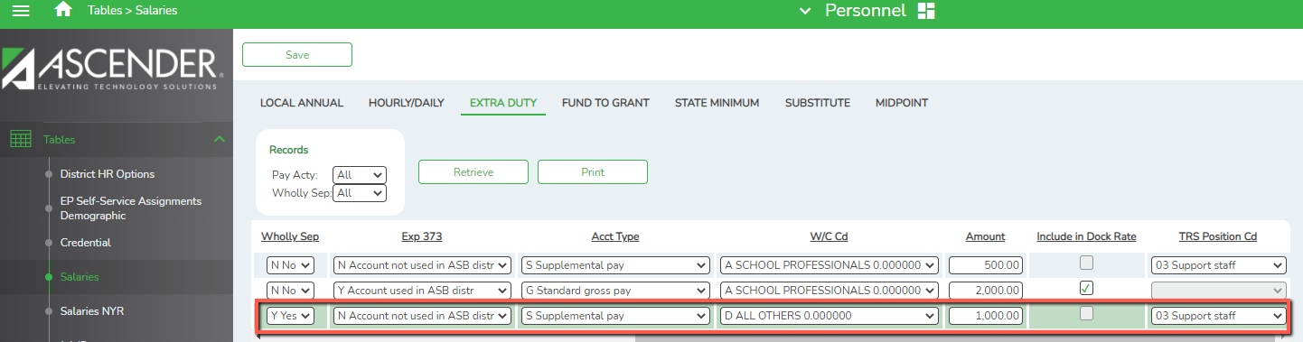

In the Pay Info tab:
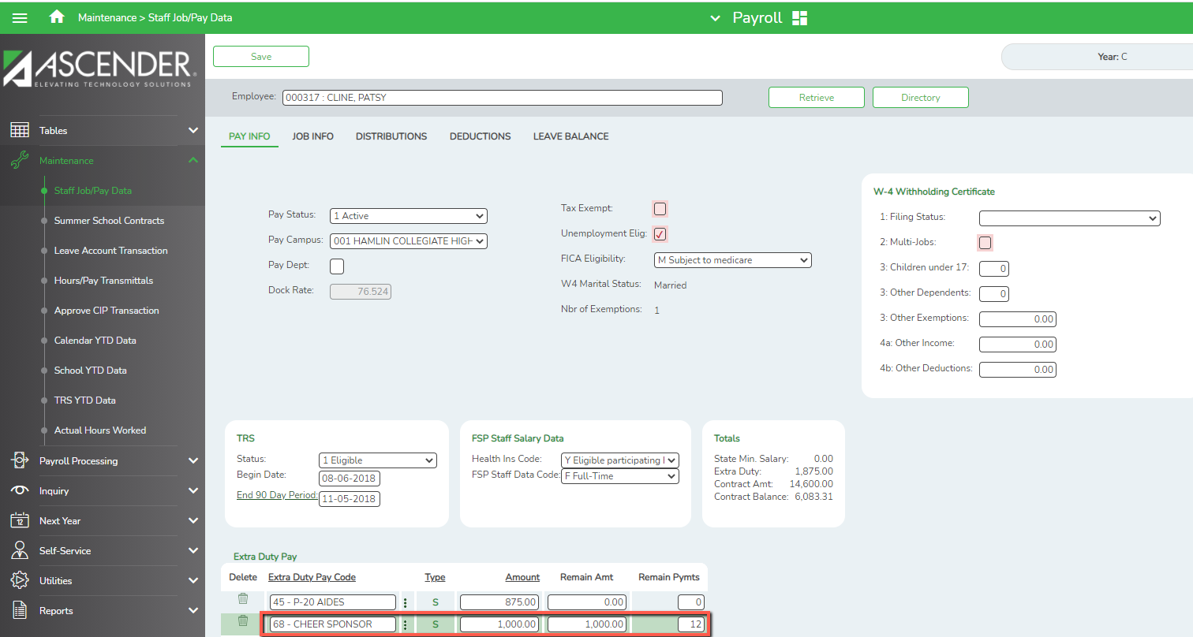
In the Job Info tab:

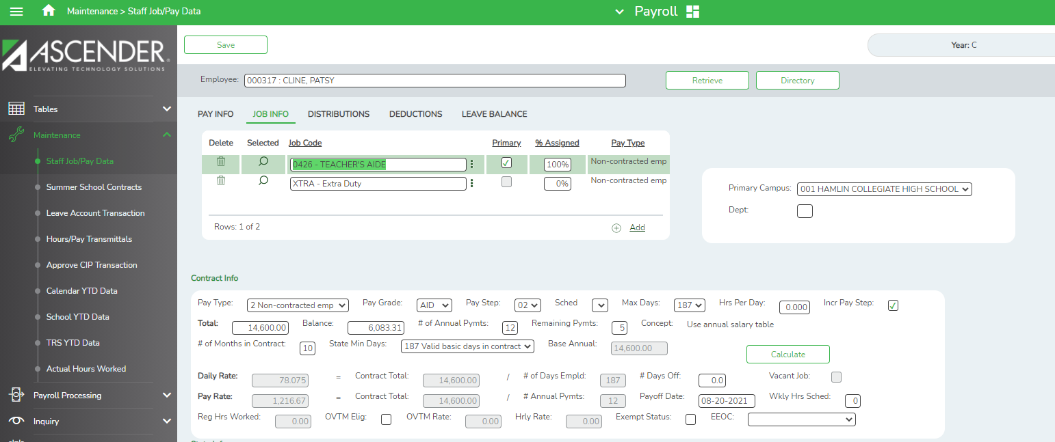

In the Distribution tab:
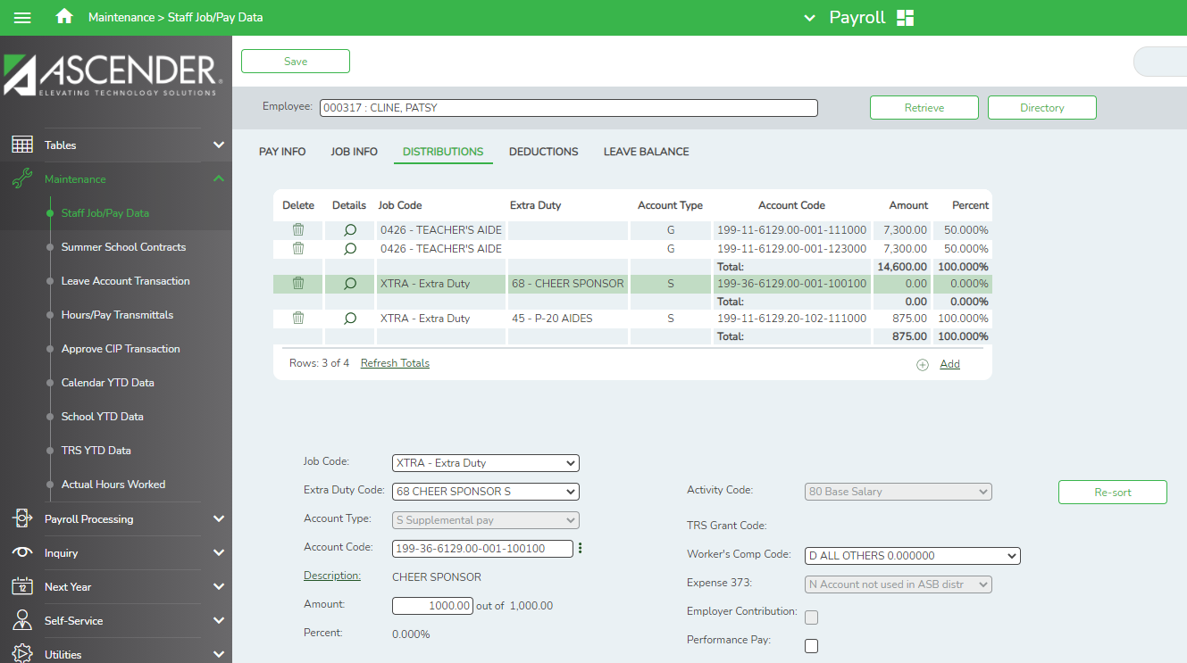
On the RP Record:
Notes for RP:
- All compensation is lumped together for Nicole’s record since all compensation is tied to TRS Position Code 03
- Stat Min is not calculated on Position Code 03

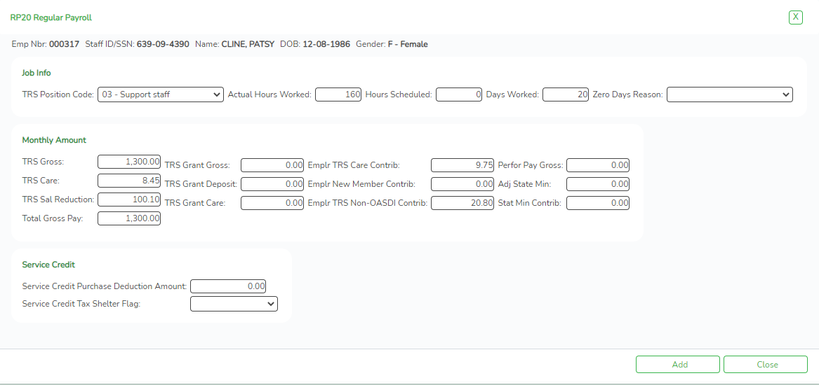

S-Type: $1,000.00 to Greta Garbo for being the 1 Act Play Sponsor

Notes:
- This S-Type will not be considered Wholly Separate so Expense 373 should be a Y.
- The TRS Position Code must be assigned and should match the same code assigned to their primary job on the Job Info screen
- When S-Types are added to an employee’s Pay Info tab, you must determine the number of annual payments, the remaining amount, and remaining payments
- An Extra Duty Job line is automatically added to the Job Info tab. There will be only one line on the Job Info tab regardless of how many S-Types are added. When deleting, the line on the Job Info tab should be deleted also if there will be no remaining S-Types for the employee.

On the Extra Duty Code table:

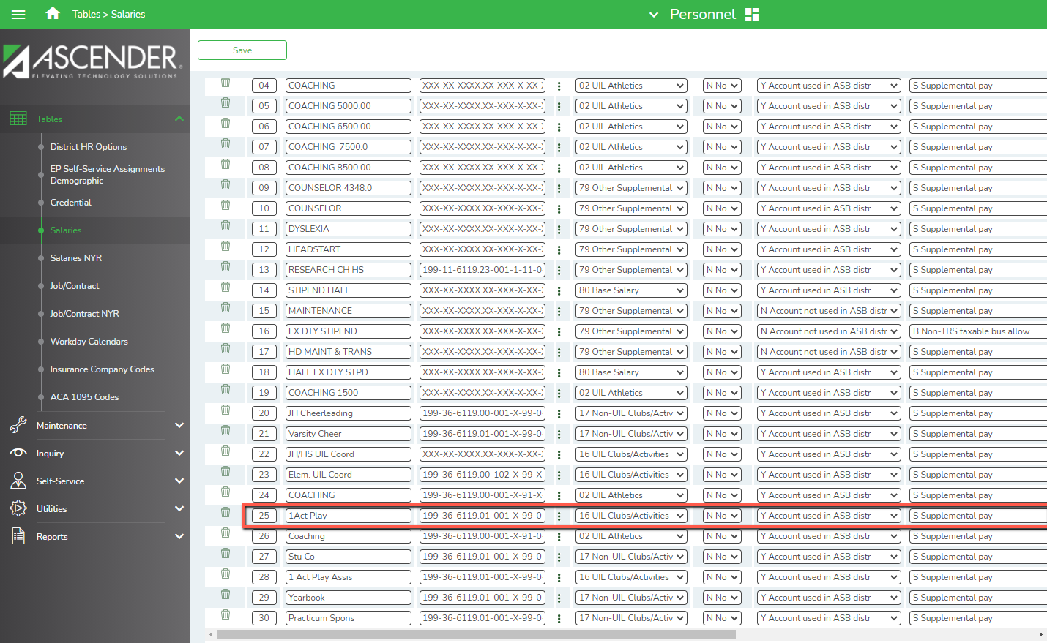
Continued…..
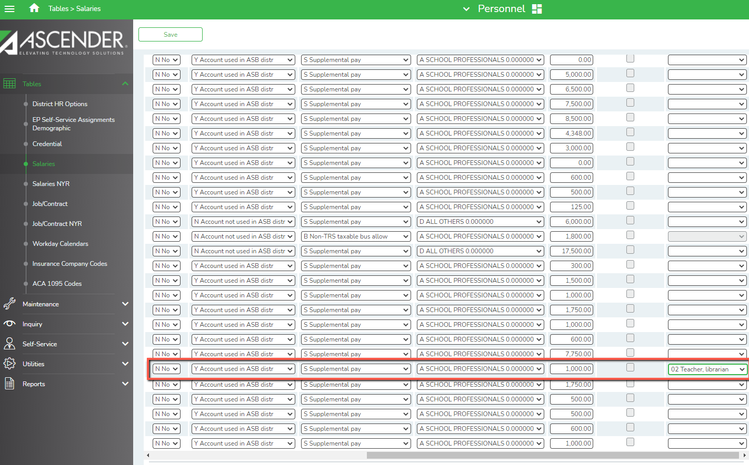

In the Pay Info tab:

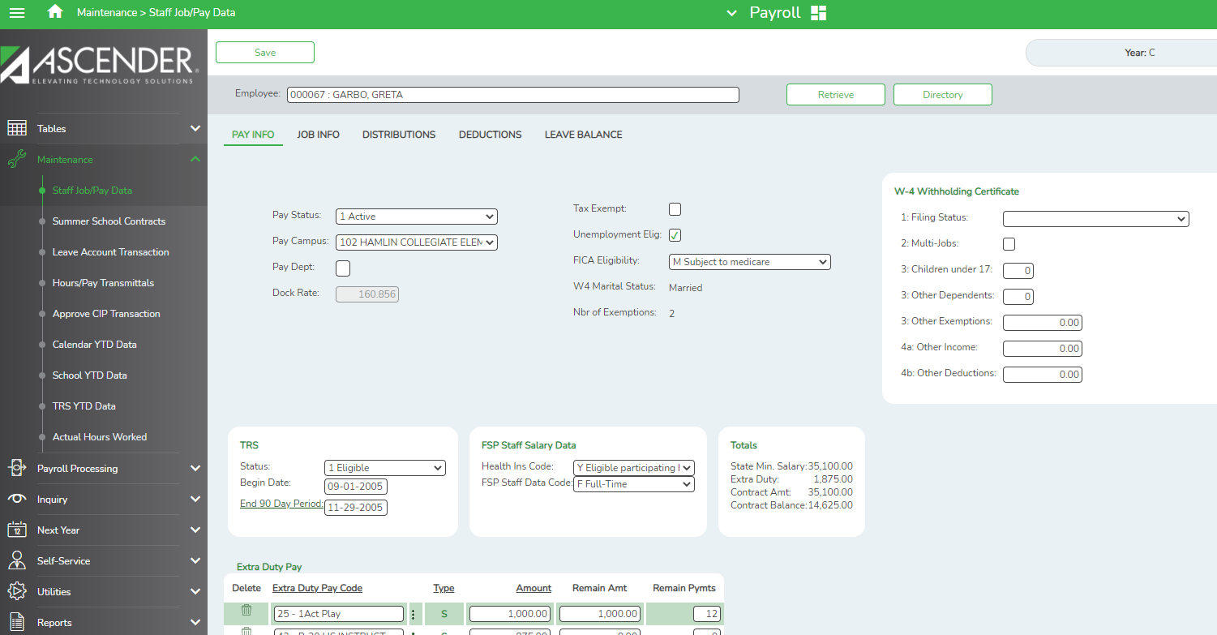
On the Job Info tab:

280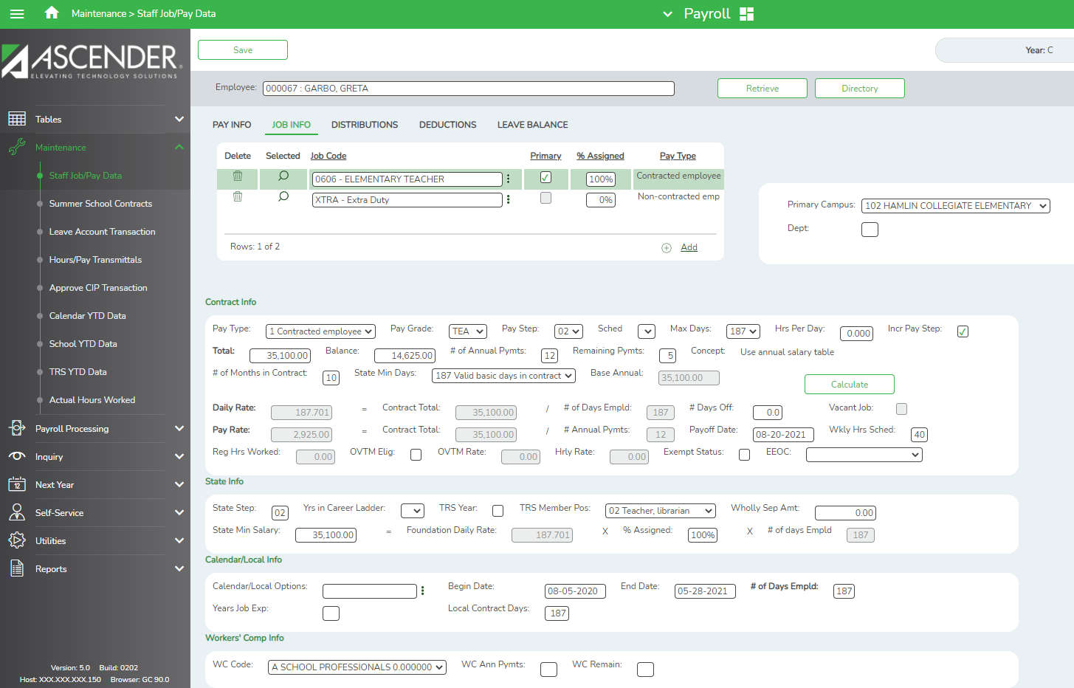

On the Distribution tab:
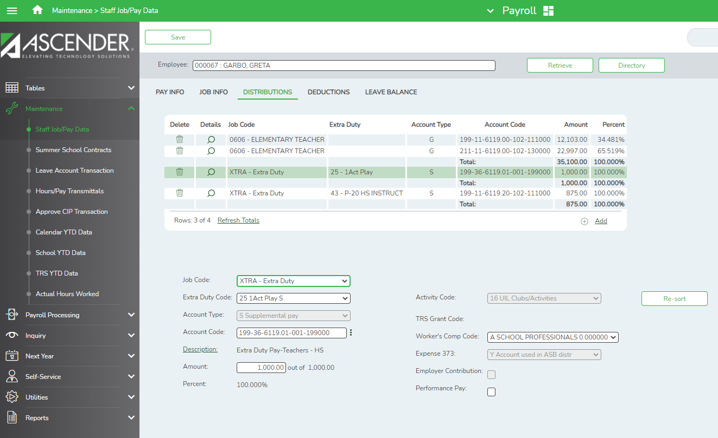

On the RP Record:
Notes for RP:
- Since the table indicated the Senior Sponsor Stipend was tied to Position 02 and not Wholly Separate (so Expense 373 showed Y so it would be included with the Stat Min calculation,) the stipend is added to the compensation paid on her primary job.

Practice Activities
- District gives stipend of $2000 to employees who earn a Master’s degree. They want to pay it out as a one-time payment in December. Currently the Superintendent, HS Counselor and 5 teachers have the degree. Explain how the Extra Duty code(s) should be created in Ascender.
- District requires their coaches to drive a bus to athletic events. A stipend of $2000 is paid to them for this service. How will this be set up in the table? Is this considered wholly separate?
- An aide also drives a bus. She typically works about 45 hours per week for the two jobs. Discuss the best way to set her up in Ascender to ensure compliance with FLSA and TRS.

One Other Consideration:

Building Stipends in the Extra Duty Code table that are used often can help ensure that compensation is reported accurately to TRS. Once built in the table, the Extra Duty Code can be selected in the Hours/Pay Transmittals screen. The selections from the table are used to populate the options on the screen.
Example:
In the Extra Duty Code table:
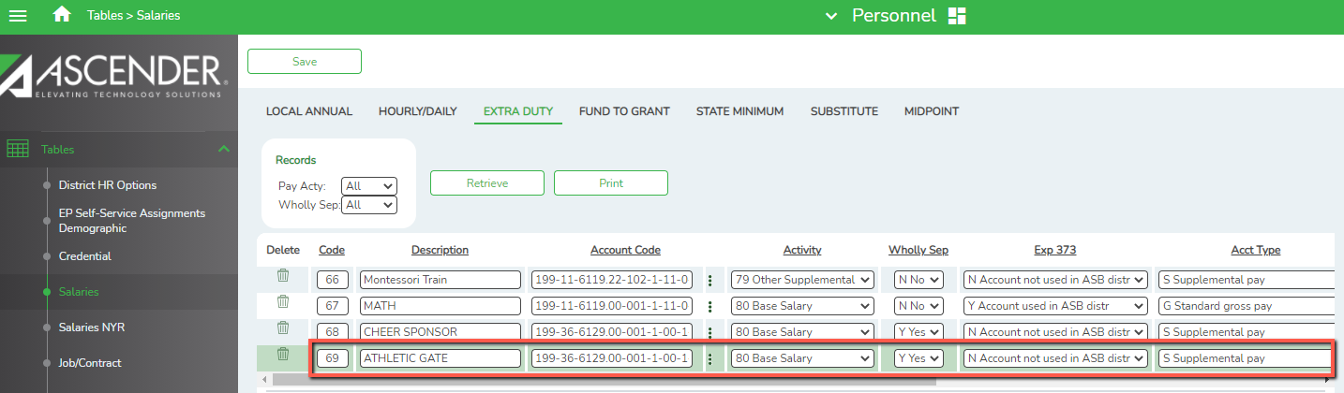
Continued….
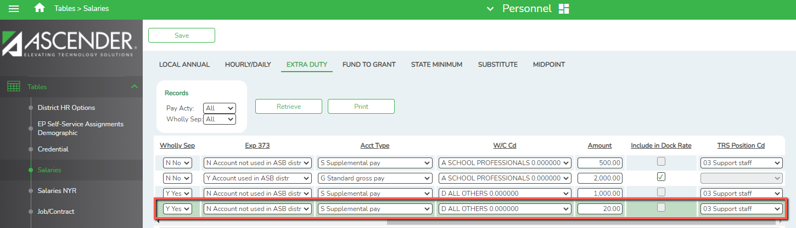

Maintenance > Hours/Pay Transmittals > Extra Duty tab:
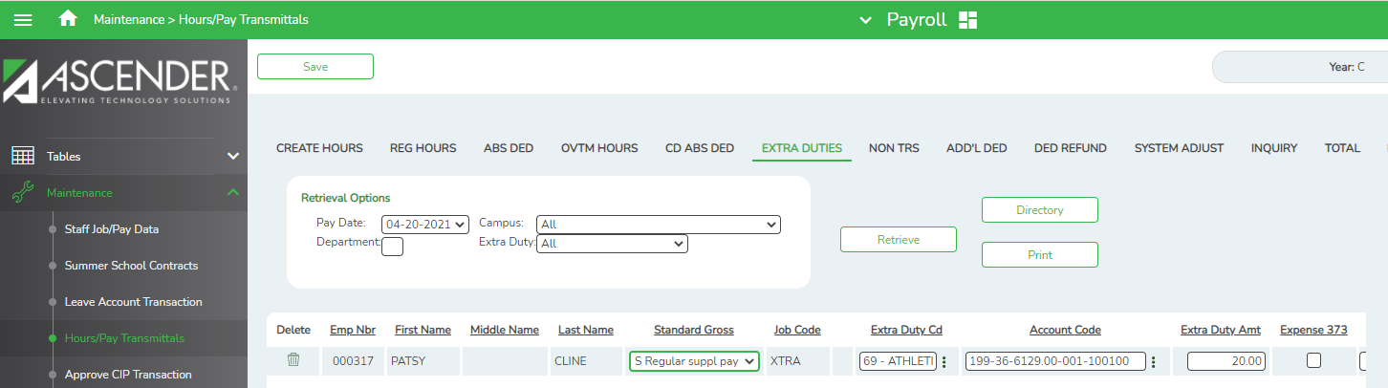
Continued….
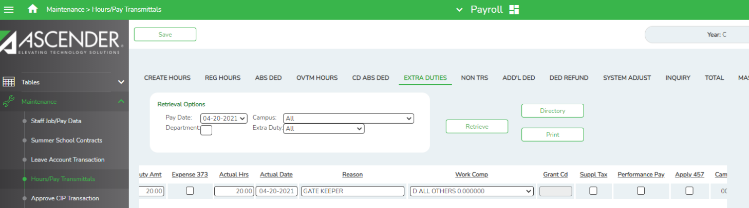

Notes:
- Multiple codes may need to be built in order to assign correct TRS Position Codes
- If a Federal Fund is used for the distribution, the Grant Code will be populated by the TRS Fund to Grant Code table
- If ED40s are needed, Ascender will create automatically when the RP20 is extracted.
- Use caution when assigning these extra duties to non-exempt staff for FLSA compliance.

